Assessment Schedule – 2015

Physics: Demonstrate understanding of wave systems (91523)

Assessment Criteria
Achievement | Achievement with Merit | Achievement with Excellence
Demonstrate understanding requires writing statements that typically show an awareness of how simple facets of phenomena, concepts or principles relate to a described situation. For mathematical solutions, relevant concepts will be transparent, methods will be straightforward. | Demonstrate in-depth understanding requires writing statements that typically give reasons why phenomena, concepts or principles relate to given situations. For mathematical solutions, the information may not be directly useable or immediately obvious. | Demonstrate comprehensive understanding requires writing statements that typically give reasons why phenomena, concepts or principles relate to given situations. Statements will demonstrate understanding of connections between concepts.

Evidence
Q | Evidence | Achievement | Achievement with Merit | Achievement with Excellence
ONE  (a) | 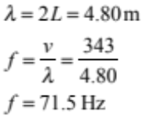 | - f = 343/4.80
(b) | Vertically: 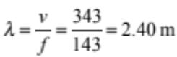 so one λ would have a fundamental note of 143 Hz.  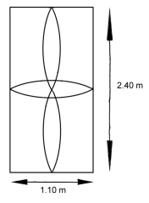  Horizontally: 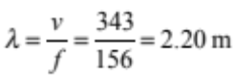 so half λ would have a fundamental note of 156 Hz. | - Correct diagram for one of the waves  - A correct calculation | - Correct diagram for both of the waves and both calculations correct.
(c) | f₃ = 180 Hz and f₅ = 300 Hz so the fundamental would be 60 Hz.  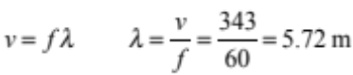  The fundamental is 4L so the blockage is 1.43m from the open end.  f₃ = 180 Hz, λ = 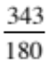 =1.91 m, 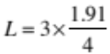 = 1.43 m  f₅ = 300 Hz, λ = 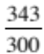343/300 = 1.14 m, 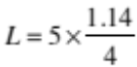 =1.43 m. | - Fundamental frequency is 60 Hz  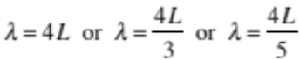  OR 1 correct drawing | - 1.43m found using  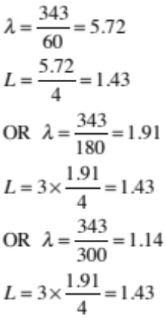
(d) | 300 Hz is no longer a resonant frequency because the sound wave is now travelling faster. f ∝ v, so the possible resonant frequencies increase.  At a speed of 1.49 × 10³ m s^{–1} a 300Hz sound has the wrong wavelength (4.97 m) to place an antinode at the open end of the pipe, as the antinode must be  (1.24m) from the node but the pipe is  1.43 m long.  The 1.43 m pipe resonates at frequencies of 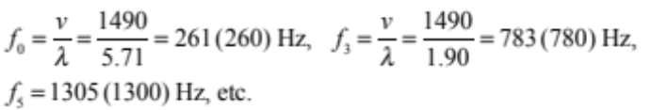  Which corresponds to wavelengths of 5.72 m, 1.91 m, 1.14 m. | - Sound waves travel faster in water.  (Replacement only) | - λ ∝ v, so wavelength increases for the same frequency  (to 4.97 m).  OR  f ∝ v so the possible resonant frequencies increase for the same pipe (same λ).  - At least one correct frequency:  f_{o} = 261 Hz,  f₃ = 783 Hz,  f₅ = 1305 Hz | - Proves that 300 Hz is not a resonant frequency by finding 260Hz and 783 Hz and making a statement comparing to 300Hz OR finding 1.91m and 5.72m and comparing to 4.97m OR using  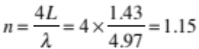  which is not an odd whole number.  OR  At this speed a 300Hz sound has the wrong wavelength to place an antinode at the open end of the pipe / node at one end and antinode at the other.  AND  States that changing the frequency to  261 Hz / 783 Hz / 1305 Hz will produce a standing wave.

Not Achieved |  |  | Achievement |  | Achievement with Merit |  | Achievement with Excellence
NØ | N1 | N2 | A3 | A4 | M5 | M6 | E7 | E8
No response; no relevant evidence. | Very little Achievement evidence. | Some evidence at the Achievement level, but most is at the Not Achieved level. | A majority of the evidence is at the Achievement level. | Most evidence is at the Achievement level. | Some evidence is at the Merit level. | A majority of the evidence is at the Merit level. | Evidence is provided for most tasks. The evidence at the Excellence level may a minor error. | Evidence is provided for most tasks and the evidence at the Excellence level is accurate.

Q | Evidence | Achievement | Achievement with Merit | Achievement with Excellence
TWO  (a) | dsinθ = nλ  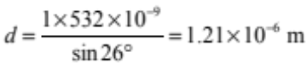 | - 1.21 × 10^{–6} m
(b) | Middle section / more lines per metre: less fringes / more space between fringes.  Edges / less lines per metre: more fringes / less space between fringes. | - Fewer/further apart fringes in the middle / more/closer fringes at the edges.  Answers must attribute fringes to interference, not diffraction.
(c) | 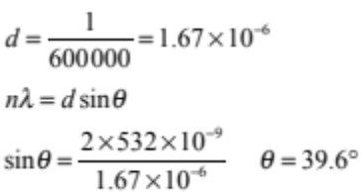 | - d = 1.67 × 10^{–6}  OR  Correct answer using n =1 (18.6º)  OR  Correct answer in radians (0.69) | - θ = 39.6°

(d) | 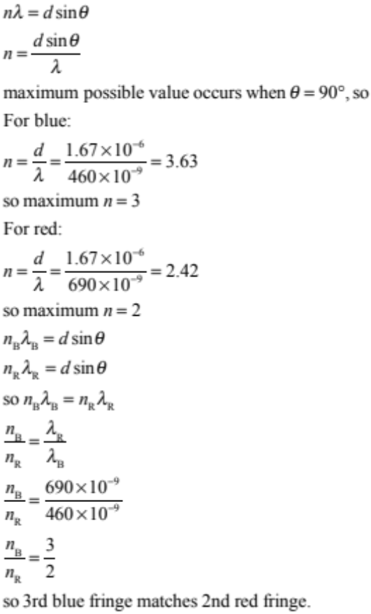 |  |  |  | - Correct use of θ ≤ 90º  OR  Maximum diffracted angle of 90º  - Zero order maximum of red and blue occurs at 0 degrees.  - Magenta / purple in the centre. |  |  | - Correct calculation for the number of maxima for blue is 3rd order/ 3 fringes each side and red fringes is 2nd order/2 fringes each side of central maximum.  OR  3rd order blue fringe coincides with 2nd order red fringe with correct working or correct angle (55.9º).  OR  0 order blue fringe coincides with 0 order red fringe with correct working. |  |  | - Correct calculation for number of maxima: 3 blue and 2 red fringes each side.  AND  Correct calculation or angle showing that 3rd blue fringe matches 2nd red fringe.  AND  Maximum possible path difference occurs at 90° and equals the distance between the slits (d) OR maximum value of sin θ = 1 OR maximum angle of diffraction stated as being 90°.
Not Achieved |  |  |  | Achievement |  |  | Achievement with Merit |  |  | Achievement with Excellence
NØ |  | N1 | N2 | A3 |  | A4 | M5 |  | M6 | E7 |  | E8
No response; no relevant evidence. |  | Very little Achievement evidence. | Some evidence at the Achievement level, but most is at the Not Achieved level. | A majority of the evidence is at the Achievement level. |  | Most evidence is at the Achievement level. | Evidence is provided for most tasks. Some evidence is at the Merit level. |  | Evidence is provided for most tasks. A majority of the evidence is at the Merit level. | Evidence is provided for most tasks. The evidence at the Excellence level may have minor errors. |  | Evidence is provided for most tasks and the evidence at the Excellence level is accurate.

Q | Evidence | Achievement | Achievement with Merit | Achievement with Excellence
THREE  (a) | Shortest wavelength when buzzer moving directly towards Sabina. | - Directly towards Sabina.
(b) | 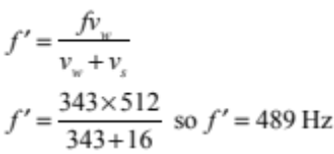 | - Correct substitution.
(c) | At point C, the buzzer has the maximum component of velocity away from Sabina, so she will hear the lowest frequency (489 Hz).  At point D, the buzzer is neither moving towards nor away from Sabina, so she will hear the actual frequency it is producing (512 Hz).  At point A, the buzzer has the maximum component of velocity towards Sabina, so she will hear the highest frequency (537 Hz). The frequency increases from 489 Hz to 537 Hz between points C and A. | - At point C, Sabina will hear the lowest frequency (489 Hz).  OR  At point A, Sabina will hear the highest frequency (537 Hz).  OR  AT point D she hears the actual frequency (512 Hz)  OR  Acceleration is towards Sabina/ velocity towards Sabina is increasing (no link to wavelength)  OR  There is a change from the decreased frequency at C / before D to the increased frequency at A / after D | - At point C, Sabina will hear the lowest frequency (489 Hz) because the buzzer has velocity away from Sabina.  AND  At point A, Sabina will hear the highest frequency (537 Hz) because the buzzer has a velocity towards Sabina.  AND a statement linking this to increasing frequency.  OR  Explains that from point C to point A the buzzer is accelerating towards Sabina/ the right and links this to the decreasing wavelength or increasing frequency received.
(d) | 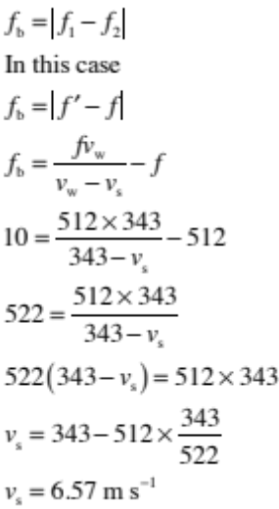 | - Calculates 522 Hz. | - Correct substitution:  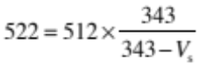 | - Correctly uses beat formula and Doppler equation to calculate maximum velocity as 6.57 m s^{–1}.

Not Achieved |  |  | Achievement |  | Achievement with Merit |  | Achievement with Excellence
NØ | N1 | N2 | A3 | A4 | M5 | M6 | E7 | E8
No response; no relevant evidence. | Very little Achievement evidence. | Some evidence at the Achievement level, but most is at the Not Achieved level. | A majority of the evidence is at the Achievement level. | Most evidence is at the Achievement level. | Some evidence is at the Merit level. | A majority of the evidence is at the Merit level. | Evidence is provided for most tasks. The evidence at the Excellence level is accurate | Evidence is provided for most tasks and the evidence at the Excellence and Merit levels is accurate.

Cut Scores
Not Achieved | Achievement | Achievement with Merit | Achievement with Excellence
0 – 6 | 7 – 12 | 13 – 19 | 20 – 24

